Making custom reports in Cucumber framework.
Step 1:
Update the MAVEN POM file with below dependencies:
<!-- https://mvnrepository.com/artifact/com.relevantcodes/extentreports -->
<dependency>
<groupId>com.relevantcodes</groupId>
<artifactId>extentreports</artifactId>
<version>2.41.2</version>
</dependency>
<dependency>
<groupId>com.vimalselvam</groupId>
<artifactId>cucumber-extentsreport</artifactId>
<version>3.0.2</version>
</dependency>
<dependency>
<groupId>com.aventstack</groupId>
<artifactId>extentreports</artifactId>
<version>3.1.3</version>
<scope>provided</scope>
</dependency>

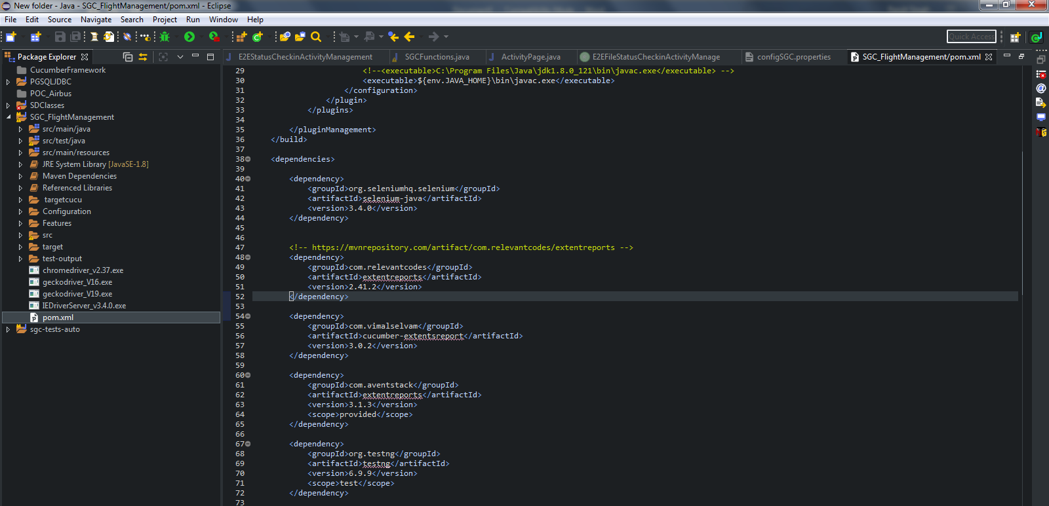
Step 2:
Add and configure extent-config.xml to your project directory
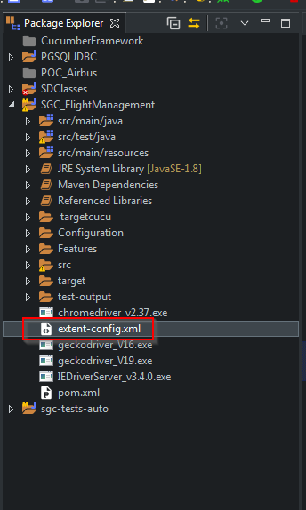
Step 3:
Amend the Runner file to include the plugin.
"com.cucumber.listener.ExtentCucumberFormatter: target/Cucumber-AdvanceReport/report.html"

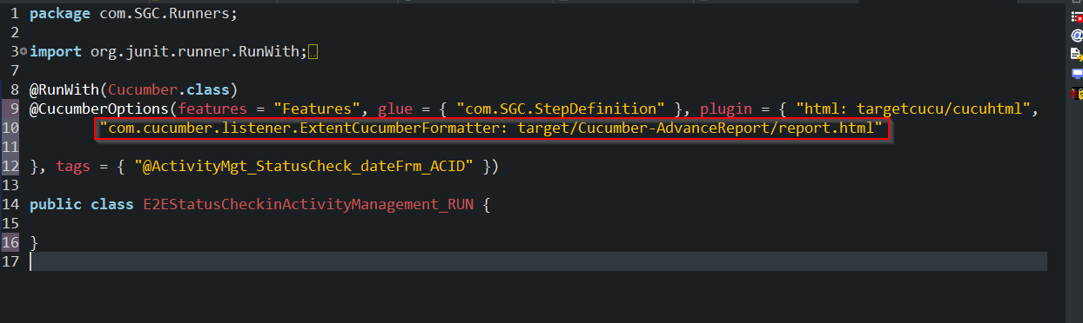

Step 4: Amend the runner file to load the config
@AfterClass
public static void reportsetup()

{

Reporter.loadXMLConfig("./extent-config.xml");

Reporter.setSystemInfo("Operating System", "Windows 7");

}

Note: Always run the runner file to generate the report.

